How to Create and Share Your Electronic Portfolio
A Guide for Tenure-Track Faculty Members

Table of Contents

Steps | Page
Step 1: Convert all documents to PDF form. 2
Step 2: Collect all required signatures 3
Step 3: Rename your PDF documents. 3
Step 4: Upload all PDF documents to a OneDrive folder. 4
Step 5: Share the OneDrive folder with your department chair(s). 5

Step 1: Convert all documents to PDF form.
ai) PC Users: Open the desired document in Word, then click “File,” then “Save as Adobe PDF.”
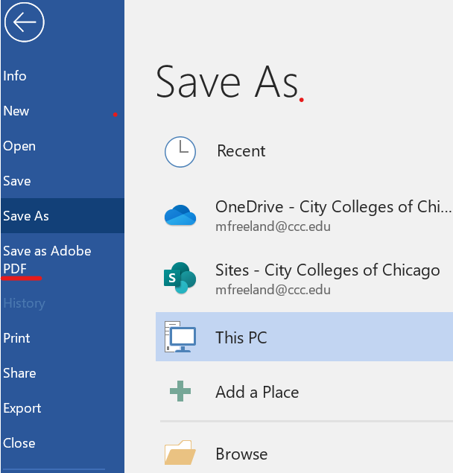

aii) Mac Users: Open the desired document in Word, then click “File,” then “Save As.” In the “File Format” box, select “PDF.” Then click “Export.”
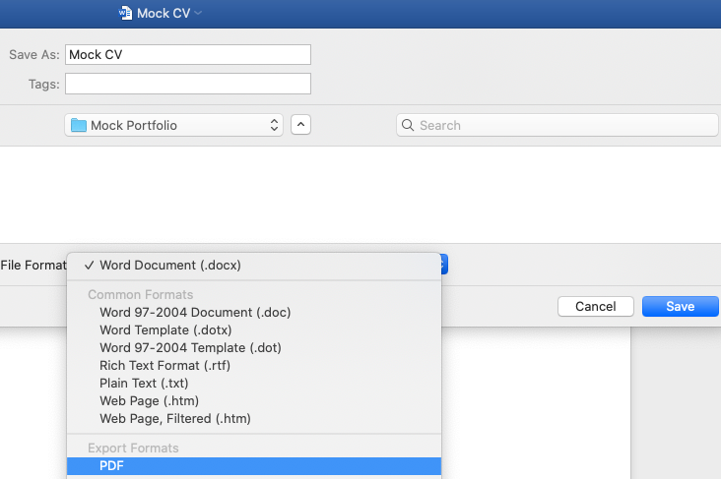

- All Users:
  - Create a folder on your local hard drive using the following naming convention: your first and last name, your current semester portfolio, and the current semester and year (i.e. “John Smith – Semester 3 Portfolio – Spring 2020”).
  - Move all PDF portfolio documents into this folder.
  - Ensure that this folder does not contain any .docx files.
  - Please note that the folder created in this step (Step 1b) will be uploaded to OneDrive and submitted as your official tenure portfolio (see steps outlined below). Be sure that you are satisfied with the documents in this folder prior to submission.

Back to Table of Contents
Step 2: Collect all required signatures.
- Go to docusign.com and log in with your CCC credentials.
- Click the following link for information on how to upload and send documents through DocuSign.
- Once your document has been signed by the required individuals, download the document to your local hard drive and proceed to Step 3 below.
- Note: While this guide only includes information on using DocuSign, there are a number of ways to collect signatures. Feel free to use whichever method you prefer.

Back to Table of Contents

Step 3: Rename your PDF documents.
- First, find your Portfolio Document Checklist, which can be found on the Resources for Department Chairs page of the CCC Tenure website.
- Next, migrate to the folder on your local hard drive containing your signed, PDF portfolio documents and rename all documents to match your portfolio checklist. To rename documents, right-click on the desired file and click “Rename.”
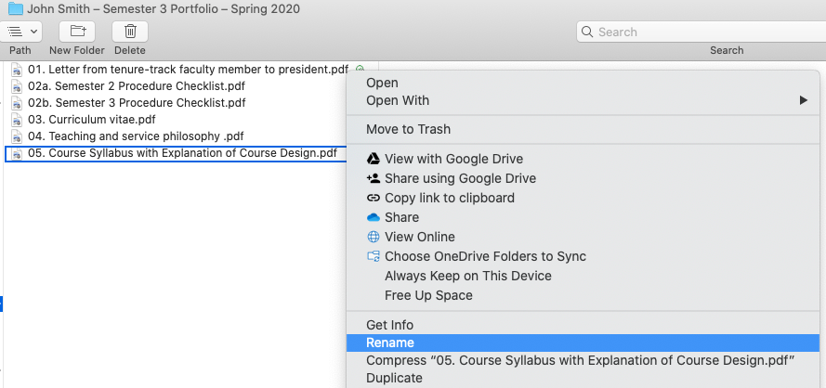

- NOTE: When renaming files, be sure that the number and name of your documents matches the number and name of the document on the portfolio checklist with one caveat – in the file name, be sure to put a “0” before numbers 1 through 9. This will be important for document organization at a later stage.
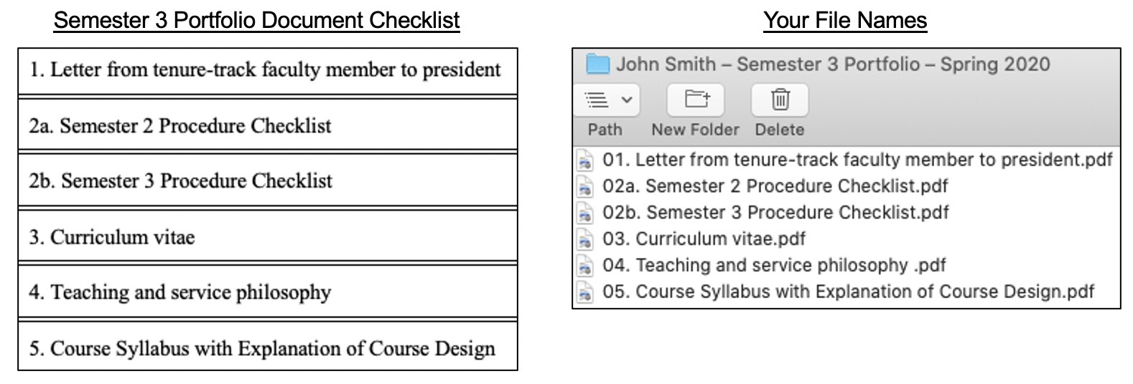

Back to Table of Contents
Step 4: Upload all PDF documents to a OneDrive folder.
- To access OneDrive, go to www.ccc.edu, hover over “Faculty and Staff,” click “OneDrive,” and log in using your CCC credentials.

- Once in OneDrive, click “Upload,” then click “Folder.”
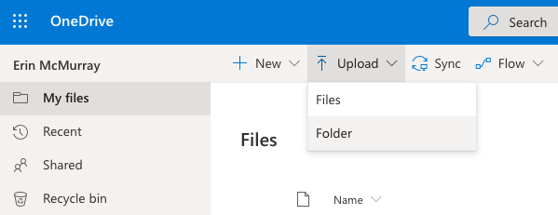

- Select the folder containing your PDF portfolio documents, then click “Upload.”
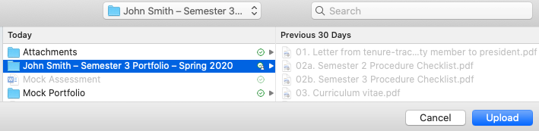

- Click on the folder to verify that all files were uploaded and that files are in the same order as they would appear in a paper portfolio. If necessary, sort the folder by name to correctly order the documents. This can be done by clicking the down arrow next to “Name” then clicking “A – Z.”
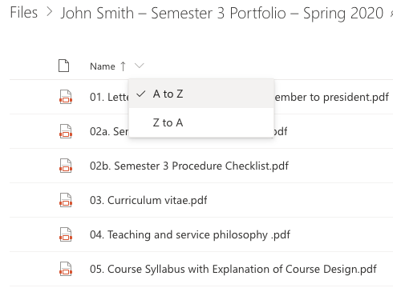

Back to Table of Contents
Step 5: Share the OneDrive folder with your department chair(s).
- Click the three vertical dots next to the folder containing your portfolio documents. Then click “Share.”
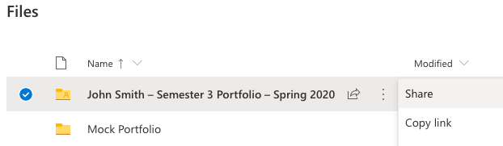

- To change the shared settings, first click “Anyone with this link can edit.”
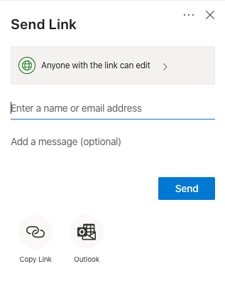

- Click “People in the City Colleges of Chicago with the link” (1), make sure the “Allow editing” box is checked (2), and click “Apply” (3). Click “Copy Link” (4) and send the link to your department chair(s) via CCC email.
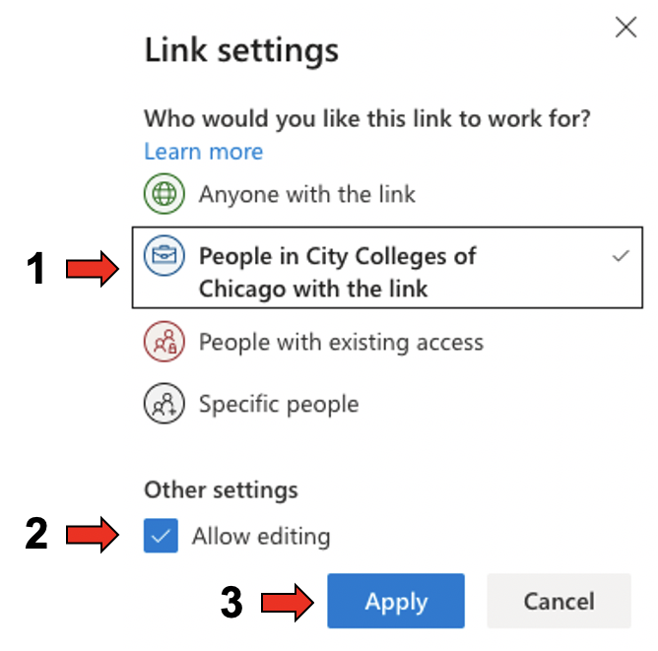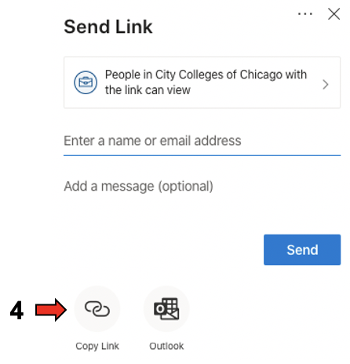

Back to Table of Contents

Once you’ve completed the steps above, you’ve successfully submitted your portfolio! Congratulations!

