Electronic Tenure Portfolios
A Guide for Department Chairs

Table of Contents

Timeline | Goals and Steps Page
Early Week 14 | Goal 1: Receive your TTFM’s portfolio; complete and upload the Portfolio Document Checklist 2  - Step 1: Receive electronic portfolio from tenure-track faculty member (TTFM) 2  - Step 2: Complete the Portfolio Document Checklist 2  - Step 3: Convert Portfolio Document Checklist to PDF 2  - Step 4: Upload Portfolio Document Checklist to TTFM’s electronic portfolio 3  Goal 2: Share the electronic portfolio with eligible department members for review 4  Goal 3: Create and share a Microsoft Forms survey for electronic contract renewal voting 5  - Step 1: Create a survey in Microsoft Forms 5  - Step 2: Adjust the form settings 8  - Step 3: Send the survey to eligible department members 9
Early Week 16 | Goal 4: Save a copy of the electronic portfolio to your OneDrive account and turn off link sharing to the TTFM’s original electronic portfolio 9  - Step 1: Save a copy of the portfolio to your OneDrive account 9  - Step 2: Remove department member access to the original portfolio 11  - Step 3: Remove department chair access to the original portfolio 12  Goal 5: Write and upload the Chair’s Letter to the President 12  - Step 1: Write the Chair’s Letter to the President 12  - Step 2: Convert the Chair’s Letter to the President to PDF 12  - Step 3: Upload the Chair’s Letter to the President to TTFM’s electronic portfolio 12
Friday of Week 16 | Goal 6: Modify the electronic portfolio name and share with college administration 13  - Step 1: Modify the electronic portfolio name 13  - Step 2: Share the electronic portfolio with college administration 14

Description of Goals and Steps

Goal 1: Receive your TTFM’s portfolio; complete and upload the Portfolio Document Checklist
Goal 1, Step 1: Receive electronic portfolio from tenure-track faculty member (TTFM)
- On Monday of Week 14, you will receive a OneDrive link to your TTFM’s electronic portfolio. The picture below is an example of part of a Semester 3 electronic portfolio:
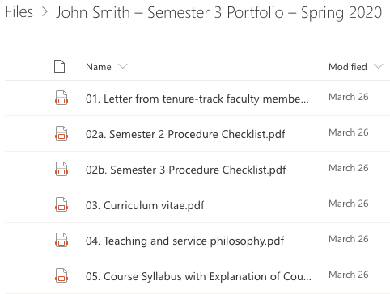

Back to Table of Contents

Goal 1, Step 2: Complete the Portfolio Document Checklist
- Download the appropriate Portfolio Document Checklist, which can be found on the Resources for Department Chairs page of the CCC Tenure website.
- Complete this checklist by referring to your TTFM’s electronic portfolio. Be sure to include your signature.
- Save the portfolio checklist with the following name: “0.3. Semester 1/3/5 Portfolio Checklist” Please note the following:
  - You should choose 1, 3, or 5 when naming the file based on your tenure-track faculty member’s semester. Please do not include “1/3/5” in the document name.
  - The “0.3.” seems arbitrary, but it’s important for final formatting of the electronic portfolio. Please make sure to include this number.

Back to Table of Contents

Goal 1, Step 3: Convert Portfolio Document Checklist to PDF
ai) PC Users: Open the Portfolio Document Checklist in Word, then click “File,” then “Save as Adobe PDF.”
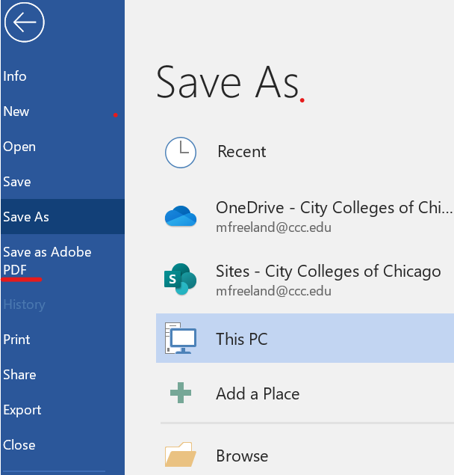

aii) Mac Users: Open the Portfolio Document Checklist in Word, then click “File,” then “Save As.” In the “File Format” box, select “PDF.” Then click “Export.”
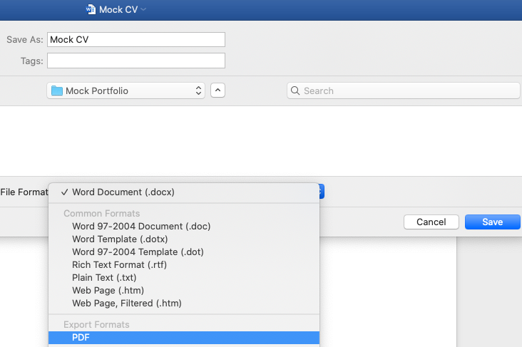

Back to Table of Contents

Goal 1, Step 4: Upload Portfolio Document Checklist to TTFM’s electronic portfolio
- Migrate to your TTFM’s electronic portfolio by clicking on the shared OneDrive link.

- Once in the folder, click “Upload,” then click “Files.”
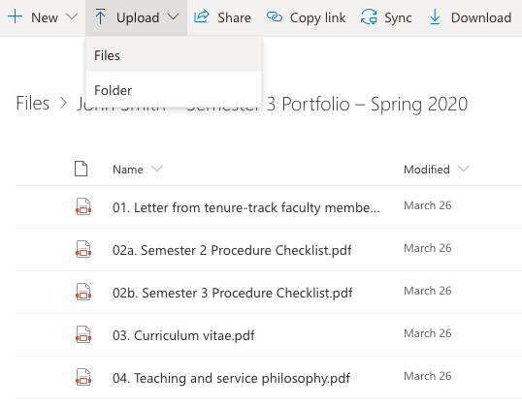

- Select the PDF version of your Portfolio Document Checklist, then click “Open.”
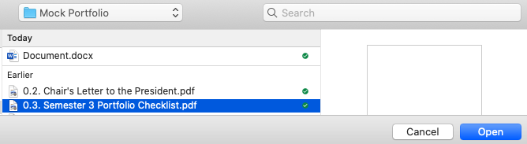

- Verify that your file was uploaded and that the Portfolio Document Checklist appears above the TTFM’s letter to the president. If necessary, sort the folder by name to correctly order the documents. This can be done by clicking the down arrow next to “Name” then clicking “A – Z.”
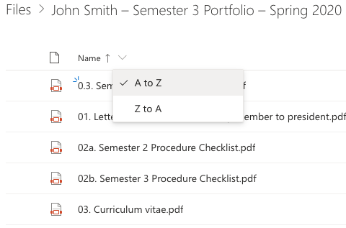

Back to Table of Contents

Goal 2: Share the electronic portfolio with eligible department members for review
- Migrate to your TTFM’s electronic portfolio on OneDrive.

- In the toolbar at the top of the page, click “Share.” Then click “Anyone with this link can edit.”
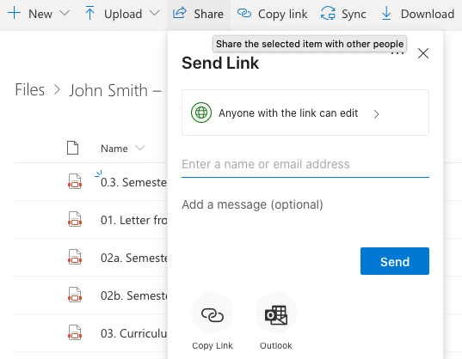

- Click “People in City Colleges of Chicago with the link” (1), make sure the “Allow editing” box is unchecked (2), and click “Apply” (3). Click “Copy Link” (4) and send the link to the eligible members of your department. Please note the following:
  - It is very important to uncheck the “Allow editing” box. This will ensure that no reviewers can change any of the portfolio documents.
  - Voting eligibility info from our Local 1600 contract: "Voting on candidates for renewal of contract other than tenure contracts shall be limited to those eligible members who have at least two semesters more continuous full-time service in the department than has the candidate except that all tenured members may vote on all candidates and only tenured members shall vote on the granting of tenure contracts."
  - It is recommended that you provide a deadline by which department members must conclude their electronic portfolio review. For example, you might consider allowing electronic portfolios to be reviewed until the Friday of Week 15.
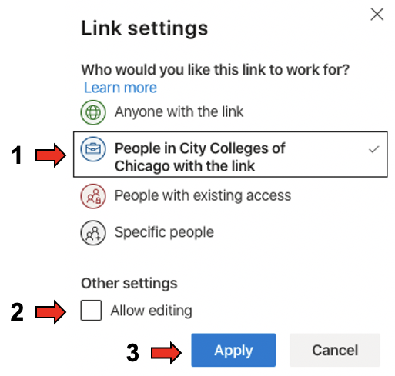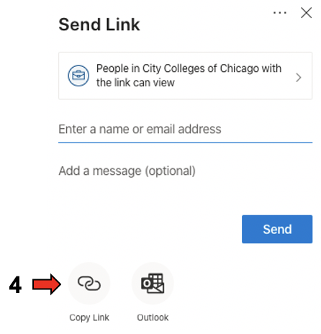

Back to Table of Contents

Goal 3: Create and share a Microsoft Forms survey for electronic contract renewal voting
Goal 3, Step 1: Create a survey in Microsoft Forms
- Go to www.ccc.edu, hover over “Faculty and Staff,” click “Email,” and log in using your CCC credentials.
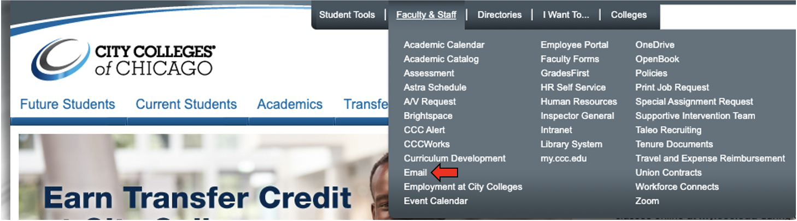

- Click the waffle icon in the top left corner, then click “Forms.”
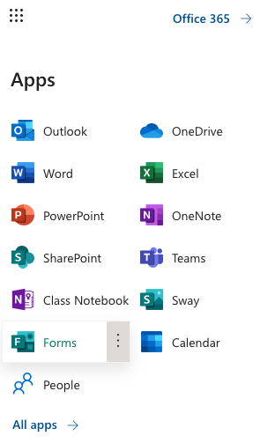

- Click “My forms” then “New Form”
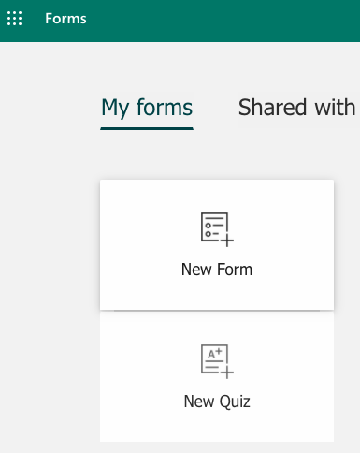

- Give the form a title, such as “Contract Renewal Vote – John Smith.” Then click “Add New.”
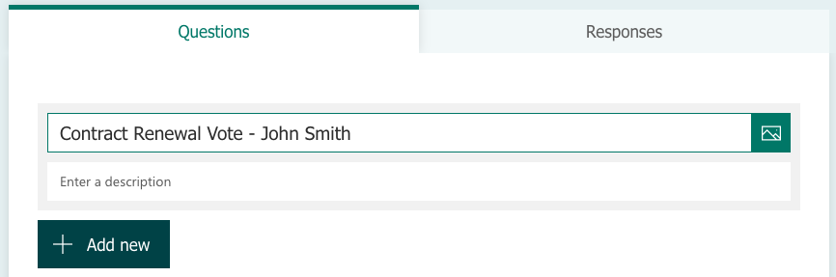

- Add questions to the form. Note: you can create any kind question you’d like here. Take a look at the picture below for an example. You can also click the following link to create a copy of the form shown below in your own account and make updates as necessary: Contract Renewal Vote Template.
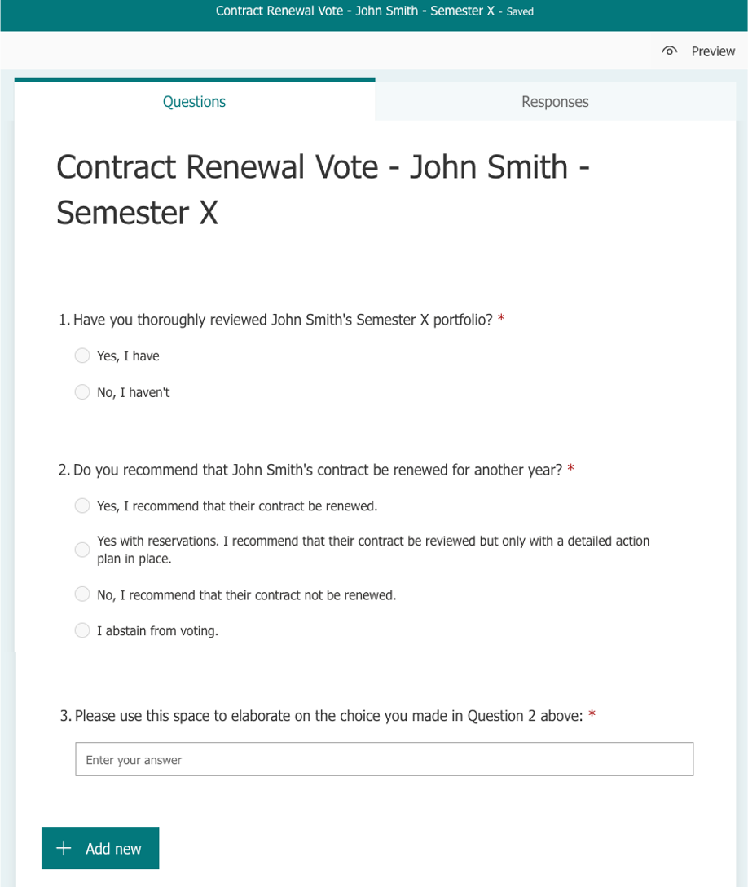

Back to Table of Contents

Goal 3, Step 2: Adjust the form settings
*Note: The goal of this step is to adjust the form settings so that only specific members of your department can vote, and all voting is anonymous.
- Click on the three horizontal dots located in the top, right corner of the form. Then click “Settings.”
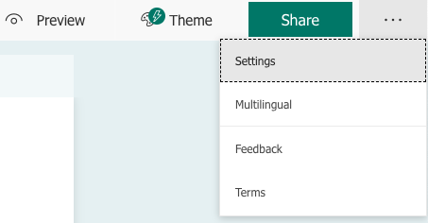

- Click “Specific people in my organization can respond” and “One response per person” as shown in the picture below. Ensure “Record name” is unchecked to collect anonymous votes. Other options such as start and end dates, thank you messages, and response receipts can be changed based on your preferences.
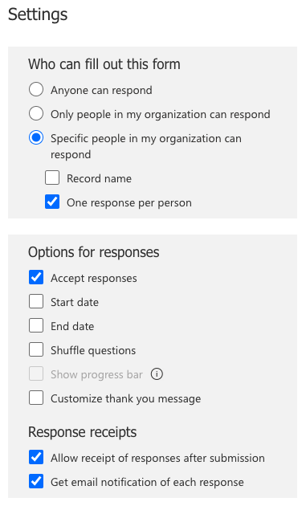

Back to Table of Contents

Goal 3, Step 3: Send the survey to eligible department members
- In the top right corner of the screen, click “Share” (1). Ensure “Specific people in my organization can respond” is chosen (2) and that link sharing is highlighted (3). Enter the names/email addresses of those department members who are eligible to vote (4). See Goal 2cii for more information on voting eligibility. Then click “Copy” (5) and email the link to all eligible department members.
*Note: This process of entering the names/email addresses of all eligible members is admittedly tedious, particularly for large departments. But this is the best way to ensure that only those members who are eligible to vote are able to do so anonymously.
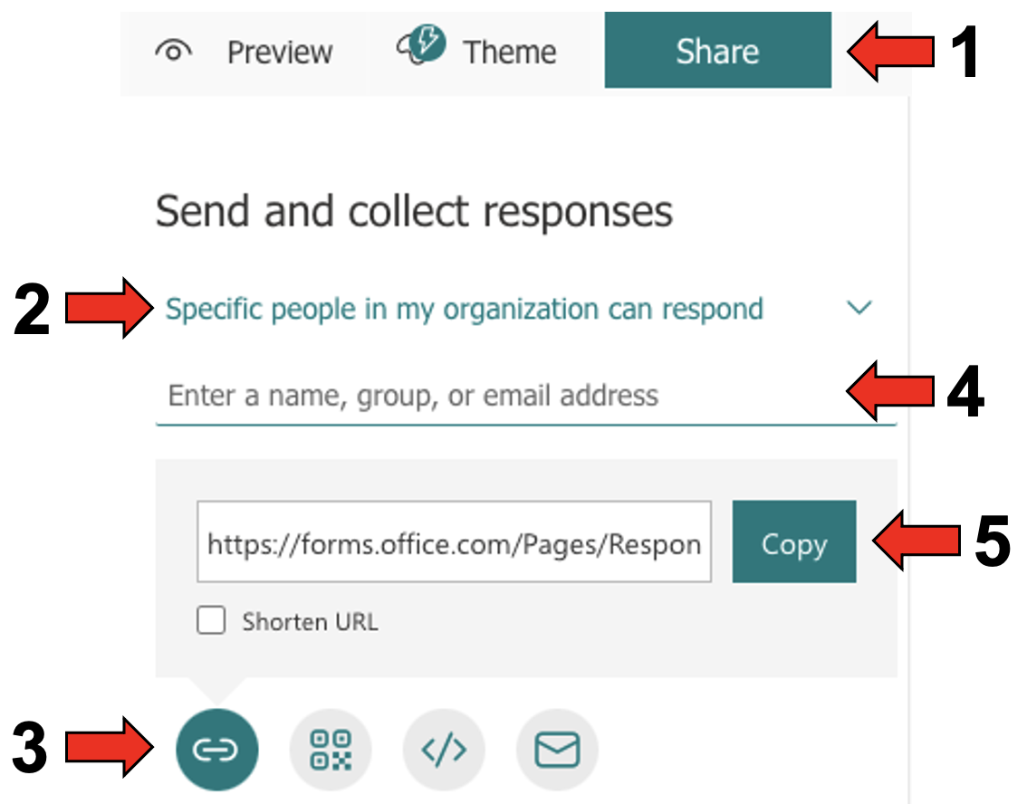

Back to Table of Contents

Goal 4: Save a copy of the electronic portfolio to your OneDrive account and turn off link sharing to the TTFM’s original electronic portfolio
*Note: The purpose of this goal is to create a copy of the portfolio that is only accessible to the department chair and eventually to college administration (see Goal 5 below). Neither the TTFM nor any department members (with the exception of the chair) should have access to this copy of the portfolio. This step should be completed only conclusion of the departmental review period.

Goal 4, Step 1: Save a copy of the portfolio to your OneDrive account
- While in the TTFM’s portfolio folder, click “Files”
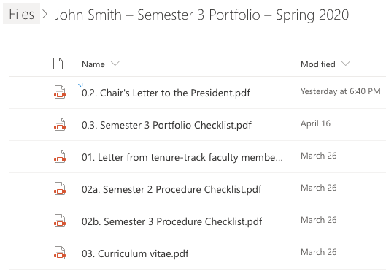

- Click the three vertical dots next to the TTFM’s portfolio. Then click “Copy to.”
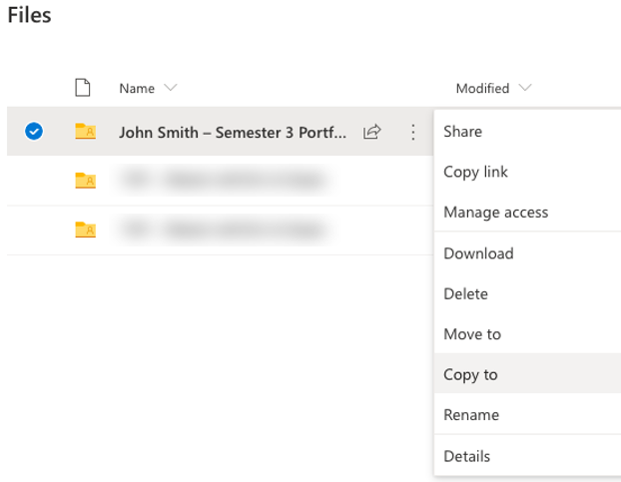

- Choose the desired location in your OneDrive account and click “Copy here” to copy the portfolio.
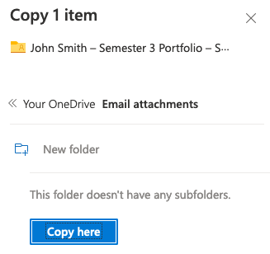

Back to Table of Contents

Goal 4, Step 2: Remove department member access to the original portfolio
- In the toolbar at the top of the page, click “Share.” Then click the three horizontal dots and “Manage Access.”
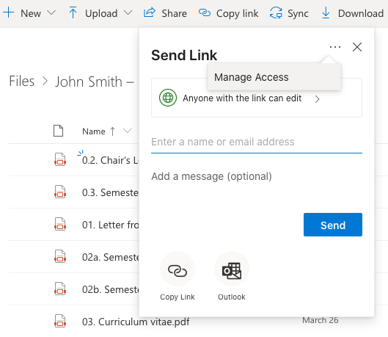

- Click the three horizontal dots next to the link with the description “People in the City Colleges of Chicago with the link can view.” This is the link that provides access to eligible department members.
  - Note: Make sure to click the dots next to the “can view” link here. Clicking the dots next to the “can edit” link will remove your access to the document.
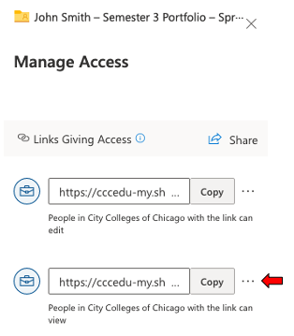

- Click the “X.”
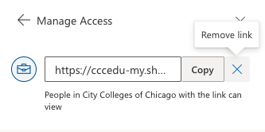

- Click “Delete link” to remove the link and associated access.
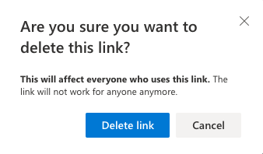

Back to Table of Contents

Goal 4, Step 3: Remove department chair access to the original portfolio
- Repeat the steps outlined in Goal 3, Step 2 above, but this time remove the link with the description “People in the City Colleges of Chicago with the link can edit.”
  - Note: This will remove your access to the TTFM’s shared portfolio. Ensure you have successfully created a copy of their portfolio in your OneDrive account prior to removal of this link.
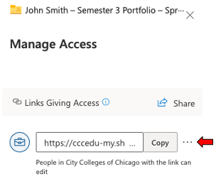

Back to Table of Contents

Goal 5: Write and upload the Chair’s Letter to the President
Goal 5, Step 1: Write the Chair’s Letter to the President
- See the following documents for more information on writing this letter: Expectations for Department Chair Letters and Sample Chair’s Letter.
- Save the Chair’s Letter to the President with the following name: “0.2. Chair’s Letter to the President” While the “0.2.” seems arbitrary, it’s important for final formatting of the electronic portfolio. Please make sure to include this number.

Back to Table of Contents

Goal 5, Step 2: Convert the Chair’s Letter to the President to PDF
- Follow the steps outlined in Goal 1, Step 3 above.

Back to Table of Contents

Goal 5, Step 3: Upload the Chair’s Letter to the President to TTFM’s electronic portfolio
- In your OneDrive account, migrate to the copy of your TTFM’s portfolio that was made in Goal 4 above.
- Follow the steps outlined in Goal 1, Step 4 to upload the document.
- Verify that your file was uploaded and that the Chair’s Letter to the President appears above the Portfolio Document Checklist. If necessary, sort the folder by name to correctly order the documents. This can be done by clicking the down arrow next to “Name” then clicking “A – Z.”
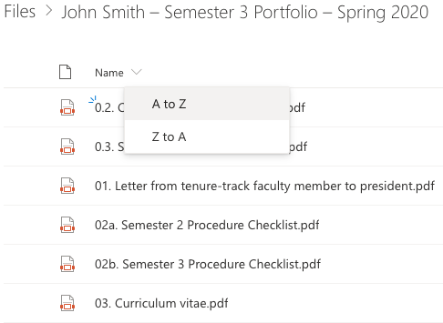

Back to Table of Contents

Goal 6: Modify the electronic portfolio name and share with college administration
Goal 6, Step 1: Modify the electronic portfolio name
- Click the three vertical dots next to the portfolio. Then click “Rename.”
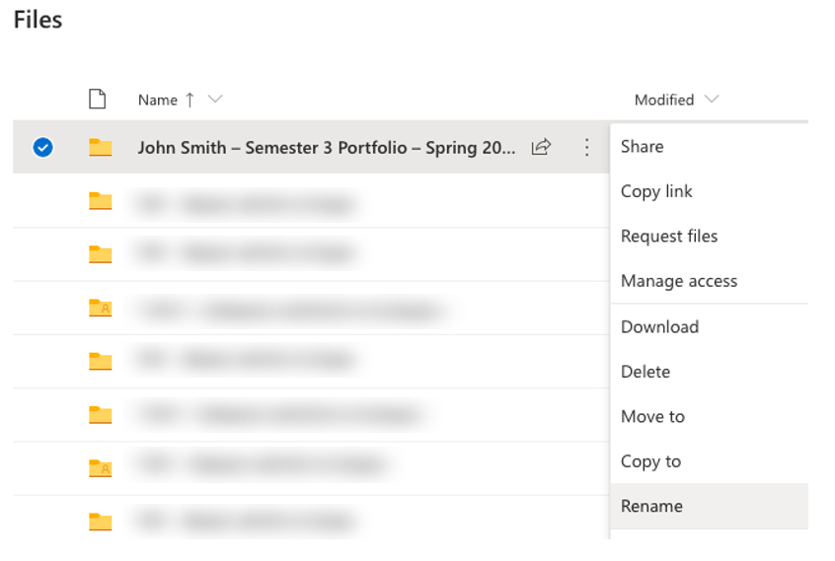

- Add “- Admin” to the end of the original portfolio name, then click “Save.” This is the portfolio that will be shared with your college administration.
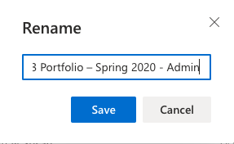

Back to Table of Contents

Goal 6, Step 2: Share the electronic portfolio with college administration
- Click the three vertical dots next to the electronic portfolio you renamed in the previous step. Then click “Share.”
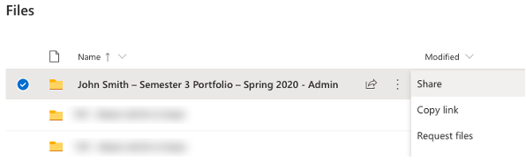

- To change the shared settings, first click “Anyone with this link can edit.”
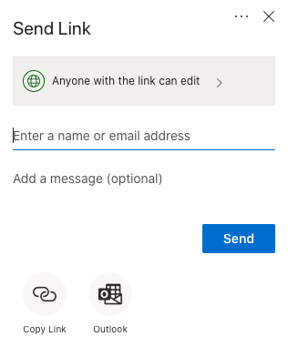

- Click “People in the City Colleges of Chicago with the link” (1), make sure the “Allow editing” box is checked (2), and click “Apply” (3). Click “Copy Link” (4) and send the link to your college administration via CCC email.

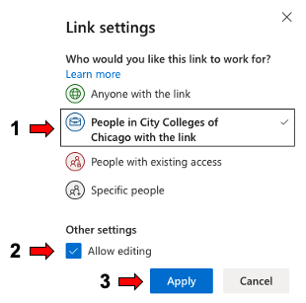

Back to Table of Contents
