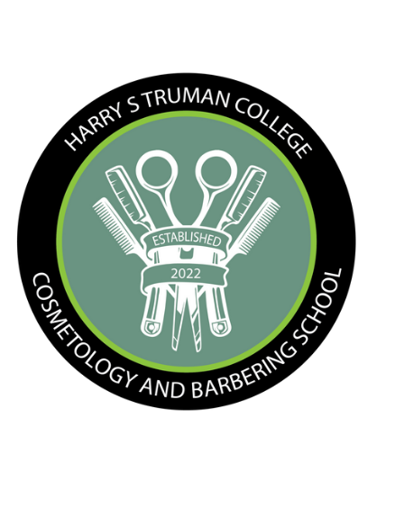

H A R R Y S T R U M A N C O L L E G E C O S M E T O L O G Y A N D B A R B E R I N G

S C H O O L

**FALL SALON SERVICE HOURS**

**SEPTEMBER 5 – DECEMBER 1, 2023**

(Service hours are subject to change without prior notice)

## **COSMETOLOGY & BARBERING**

## **BEAUTY SALON**

**Cosmetology Salon Service Hours**

**Tuesday – Thursday: 10:30 am – 2:30 pm**

**Wednesday: 5:00 pm – 6:30pm**

**Friday: 9:00 am – 1:00 pm**

**Barber Salon Service Hours**

**Monday and Thursday: 9:30 am – 2:30 pm**

**Monday through Thursday: 3:30 pm – 6:30 pm**

**Friday: 3:30 pm – 6:30 pm**

***All services are free of charge. Services are limited to one service per day.***

***Services are offered on a “first come, first served” basis.***

***All client services are provided on a walk-in basis. The number of clients served each day will depend on the number of students present. If students are taking exams, on a field trip, or not in the salon, we are not able to serve clients. You must have a photo ID, and be 18 years of age or older to receive services. There are no color services conducted on Mondays, however, you may have a patch test on a Monday for a Tuesday application. All color services require a patch test before complete application. Only clients receiving services are allowed in the salon area. Clients are required to take down all braided styles before services are provided. All work is done exclusively by students. Harry S Truman College Cosmetology School reserves the right to refuse services.***

