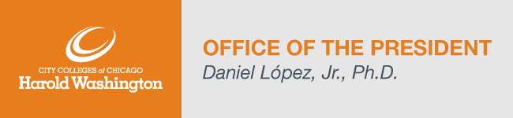
Dear Harold Washington College Community,

I want to thank the entire HWC community for their amazing generosity this week. We had more than a dozen volunteers supporting our Spring 22’ Enrollment Call Campaign. We had even more members of the HWC community donate to, and share information about, our Giving Tuesday College Scholarship Fund! Your time, effort, money, and support, help to further the Harold Washington College mission. And I want to thank you!

There’s still time to donate to the Giving Tuesday College Scholarship Fund. This year, I will match up to $5,000 in employee donations! For your donation to be matched, please donate to the Giving Tuesday College Scholarship Fund campaign (https://givebutter.com/GIVEHW2021) and set-up a separate recurring payroll deduction to the Harold Washington Scholarship Fund by Friday, December 17th.

Together, we can give the gift of education.

Here are the College Updates for this week:
- Enrollment Update (updated December 2nd)
Spring 2022 – 16-week session - Headcount: 1,150, Credit Hour: 10,726
Registration for spring 16-week classes remains open. To learn more about our registration process, click here.
- Faculty and Staff Accomplishments
We are excited to share recent accomplishments from our faculty, staff members and students. Please forward accomplishments to Shiang-Kwei Wang, Vice President of Academic and Student Affairs at swang56@ccc.edu.
- 2021 Holiday Safety Tips
Can be found here.
- COVID FAQ’s
Can be found here.

Highlighted Upcoming Events:
- The HWC Dance Program’s Ballet and Hip-Hop Demonstration is scheduled for Monday, December 6th, at 11:30am in Room 103.
- Phoenix4U invites you to beat the stress of the Holiday Season with a therapeutic mixed media art event. Monday, December 6th, 12pm – 2pm, Room 1115. Art materials provided!
- Students enrolled in Theatre Art 132 & 133 will showcase their acting and directing skills on Wednesday, December 8th, in Room 103. The Directing Showcase will take place at 1:30pm and the Acting Showcase will be held at 4:00pm. It’s free!
- Calling all Artists and Writers! The Garland Court Review, Harold Washington’s annual Literary Journal, is seeking submissions for the 2022 print issue. All HWC students, faculty, and staff are eligible to submit! The Early Bird deadline is December 18, 2021. Contact Jean-Laurent Deher-Lesaint or Galina Shevchenko to submit.
- For a complete list of announcements please visit our HWC Announcements page. The HWC Events Calendar lists all upcoming events for students, faculty, staff, and the public.

Personnel Updates and Searches (updated November 19th):
- Associate Dean – Career Programs – Interview scheduling in-progress.
- College Clerical Assistant – Interviews scheduled.
- Dean of Instruction – Finalist submitted for December Board.
- Associate Dean of Enrollment Management – Finalist submitted for December Board.
- Human Resources Business Partner - Interviews scheduled.

