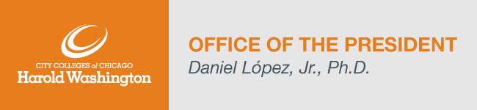
Dear Harold Washington College Community,
The beginning of a new calendar year always brings fresh energy, and I feel especially thrilled to welcome back faculty, staff, and students to another exciting semester here at Harold Washington College! Along with anticipation and energy, I know some in our community are anxious about the persistent pandemic and latest viral strain. With the combination of districtwide measures, including our high vaccination rate, mask wearing, mixed modality course schedule, and weekly testing; I believe that we’re in a strong place to respond.
Faculty and staff are preparing for our Spring ’22 Radical Welcome, a weeklong event of greeting students back to campus during the start of the semester. I want to thank all that have volunteered to support this vital initiative.
I’d also like to thank everyone who helped support the Giving Tuesday and End of the Year Scholarship Fund Campaign. In addition to the multiple employees that initiated recurring payroll deductions and a large corporate donation, we received over $3,000 in community contributions!
Various departments have already begun to build on the momentum of such a great year-end. Over the holiday break our Super Saturday event was transitioned to an entirely virtual experience. This is an electrifying time for HWC as we engage in these opportunities to battle challenges through collaboration and agility.
I am deeply grateful to each of you for your extraordinary dedication to our students; I am honored to be a part of such a remarkable and talented community.
I wish everyone all the best for a healthy, safe, and productive semester.
Here are the College Updates for this week:
- Enrollment Update (updated January 6th)
Spring 2022 – 16, 12, and 8-week sessions - Headcount: 2,827; Credit Hour: 29,968*
Registration for spring classes remains open. To learn more about our registration process, click here.
*Counting credit hours for all CCC students registered for courses held at HWC.
- Faculty and Staff Accomplishments
We are excited to share recent accomplishments from our faculty, staff members and students. Please forward accomplishments to Shiang-Kwei Wang, Vice President of Academic and Student Affairs at swang56@ccc.edu.
- Spring 2022 COVID FAQ’s
Can be found here.

Highlighted Upcoming Events:
- For a complete list of announcements please visit our HWC Announcements page. The HWC Events Calendar lists all upcoming events for students, faculty, staff, and the public.

Congratulations and Welcome to the following new hires:
Please take a moment to help welcome the following people to their new positions:
- Melissa McGlynn, Associate Dean – Enrollment Management
- Morgan Araujo, Human Resources Business Partner

Personnel Updates and Searches (updated December 6th):
- Associate Dean, Career Programs – Interviews scheduled
- College Clerical Assistant – Interviews scheduled.
- Director, First Year Experience – Position posted.
- Teacher Assistant, Printmaking – Position posted.
- College Advisor – Position posted.
- Career Services Advisor – Position posted.
- Adjunct Instructor, Architecture – Position posted.
- Clinical Counselor, Wellness Center – Position posted.
- Adjunct Instructor, Spanish – Position posted.
- Director, Auxiliary Services – Position posted.
- Director, Continuing Education – Position posted.
- Part-Time Security Officer – Position posted.
- Clerical Assistant II, Admissions – Position posted.
- Adjunct Instructor, English Language Learning – Position posted.
- Adjunct Instructor, Child Development – Position posted.
- Assistant Dean, Early College -Position posted.
- Assistant Director, Research and Planning – Position posted.
- Janitor – Position posted.

