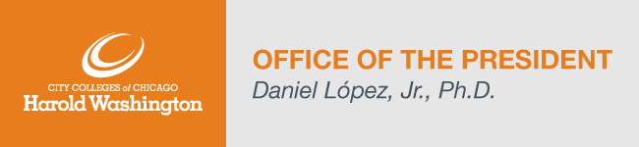
Dear Harold Washington College Community,

Thursday marked the launch of the new HWC Citizens Leadership Center, one of only 10 in the nation! This center supports the HWC vision of providing students with the skills required to be agents of change for their communities. If you missed yesterday’s event, I encourage you to register for the self-paced No Blame Problem Solving course, a course aimed at empowering the community in civic service.

Another great opportunity to discuss change is our recently rescheduled Open Forum with Provost Potter. During this forum, you’ll have the opportunity to share your concerns, questions, and thoughts. The forum is now scheduled for Wednesday, December 1st, from 3:30pm to 5pm. An email invite will be sent early next week.

Before you begin your holiday break, please take some time to review the HWC Safety and Security Department Holiday Safety Tips. Please also note that the campus will be closed for the Thanksgiving Holiday on Thursday, November 25th and Friday, November 26th, and will reopen on Saturday, November 27th at 7:30am.

Before ending my last weekly update for the month of November, I just want to say how thankful I am to have each and every one of you as part of the Harold Washington team! Enjoy your well-deserved time off and have a wonderful holiday break!

Here are the College Updates for this week:
- Enrollment Update (updated November 18th)
Spring 2022 – 16-week session - Headcount: 794, Credit Hour: 7,536
Registration for spring 16-week classes remains open. To learn more about our registration process, click here.
- Faculty and Staff Accomplishments
Congratulations to Vanessa Johnson (College Bursar) who will appear as a contestant on Wheel of Fortune! Vanessa’s air-date is November 23rd.
We are excited to share recent accomplishments from our faculty, staff members and students. Please forward accomplishments to Shiang-Kwei Wang, Vice President of Academic and Student Affairs at swang56@ccc.edu.
- Library Newsletter
For access click here.
- COVID FAQ’s
Can be found here.
- Employee Directory
Our new Employee Directory is available at http://directory.ccc.edu.

Highlighted Upcoming Events:
- Calling all Artists and Writers! The Garland Court Review, Harold Washington’s annual Literary Journal, is seeking submissions for the 2022 print issue. All HWC students, faculty, and staff are eligible to submit! The Early Bird deadline is December 18, 2021. Contact Jean-Laurent Deher-Lesaint or Galina Shevchenko to submit.
- The faculty-led Assessment Committee encourages students to complete the HWC Assessment Survey by Tuesday, November 30th.
- For a complete list of announcements please visit our HWC Announcements page. The HWC Events Calendar lists all upcoming events for students, faculty, staff, and the public.

Personnel Updates and Searches:
- Associate Dean – Career Programs – Interview scheduling in-progress.
- College Clerical Assistant – Interviews scheduled.
- Dean of Instruction – Finalist submitted for December Board.
- Associate Dean of Enrollment Management – Finalist submitted for December Board.
- Human Resources Business Partner - Interviews scheduled.

