Information Technology
  - FY 17 Accomplishments

Table of Contents
- Accomplishments 1

- Data 2
Open Lab Analytics
Kiosks Usage
Help Desk Tickets

Accomplishments
- Deployed 9 new servers to the S308 NET Tech classroom to be used for networking, forensics, and virtualization classes.
- Refreshed the computer lab in L123 with a total of 37 new computers
- Deployed 4 computers for Biology tutoring in L211.
- Assisted with the deployment of the Canon copiers.
- Assisted with the deployment of the Ricoh MFPs.
- Deployed MS Office 2016 to 1,800 computers and laptops.
- Deployed 40 laptops to HP Room 309 for future programming classes
- Assisted with the Cisco switch upgrade at Humboldt Park as part of the network infrastructure equipment refresh in order to improve the network bandwidth.
- Assisted with the deployment of SCCM at the main campus and Humboldt Park.
- Deployed 11 Windows computers to L116. This expanded lab time available to the faculty.
- Deployed 3 Microsoft Hubs along with training manuals. Two at the main campus and one at Humboldt Park Room 309.
- Updated 11 projectors in Multimedia classrooms A200, A221, A333, A334, L113, L130, L123, S247, S216, S244 and E202.
- Configuration and implementation of Qnomy ticketing system and its use at the Wright Stop Shop and peak registration.
- Provided Qnomy training to the staff.
- Installation of Qnomy equipment in the One Stop and Events Atrium.
- Configuration and implementation of Ad-Astra scheduling.
- Installed projector remotes in 7 LRC computer labs. (L113, L115, L116, L119, L123, L128, L130)
- Provided technical support and training for 102 Smart and Multimedia Classrooms.
- Provided technical support and training for 7 Conference Rooms at Wright and 2 at Humboldt Park.
- Provided 2,542 multimedia carts for classroom use.
- Provided 817 equipment set-ups and assistance for various events, meetings or training.
- Planned and deployed IT equipment and network infrastructure for the Cyber Security class by the Department of Defense.
- Installed AV equipment for DoD classes. (S237A, S237B, S237C and S237D)
- Provided streaming of events to Humboldt Park campus.
- Assisted faculty with various classroom projects by developing procedures and manuals along with providing hardware and software training for both faculty and students.
- Completed HP 211 AV and network racks equipment installation
- Completed computer lab refresh in room S244, A302, Gateway and Advising computers, and registration laptops.
- Media services staff completed training in Photoshop CS6, Crestron 101, Crestron Toolbox, Whiteboard Smart Technology Training 1, Whiteboard Smart Technology Training 2, Adobe After-Effects, Skype, and Microsoft Suite Certification.
- Deployed new informational mobile kiosks at the main campus (2) and at the Humboldt Park campus (1).
- Upgraded the Netlabs network equipment for the NetTec and A+ student by adding an additional POD.
- Completed the computer rename project as part of the Active Directory Governance policy.
- Arranged and provided Microsoft training to the Wright College faculty and staff on OneNote for classroom
- Arranged and provided Microsoft training to the Wright College IT staff on the MS Hub maintenance and support
- Arranged and provided Microsoft training to the Wright College faculty and staff on using the Microsoft Hub.
- Purchased equipment for the Makers Space

Data

Open Lab Analytics

The open lab (L120) received about 57,072 visits from November 2016 to June 2017. A visit is consider when a given end-user is active using a computer.
1
2
3
Google Chrome
MS Word
Firefox
Most Used Applications

57,072 Visits
FY 2017

Kiosks Usage

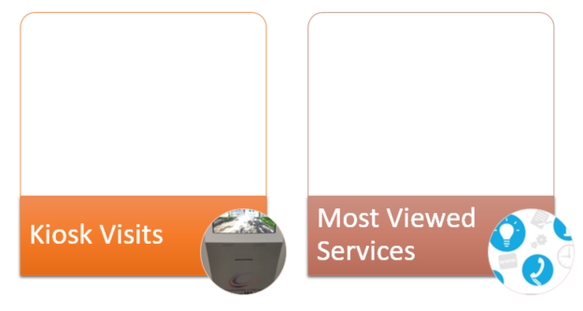
Shuttle Bus
Campus Map
CTA Bus Tracker
2
3
1

Help Desk Tickets

Item | Value
Completed Tickets | 7,013
Average Time Resolution | 2 days 11 hours
Tickets Open > 3 days | 18%

Computer Labs

A total of 736 computers in our labs at the main campus and 158 computers at Humboldt Park.
